# Report on the total number of patients seen by each doctor

**Explanation**: This report provides information on the total number of patients seen by each doctor. It joins the appointment and doctor tables using the doctor_id field, and groups the results by doctor. The COUNT aggregate function is used to count the number of patients seen by each doctor. This report can help the hospital administration to understand the workload of each doctor and assign resources accordingly.

**Business Benefit**: This report helps the hospital administration to understand the workload of each doctor and assign resources accordingly, thereby improving the hospital's operational efficiency.

SELECT d.doctor_id, d.doctor_name, COUNT(*) AS patient_count

FROM Appointment a

JOIN doctor d ON a.doctor_id = d.doctor_id

GROUP BY d.doctor_id, d.doctor_name;

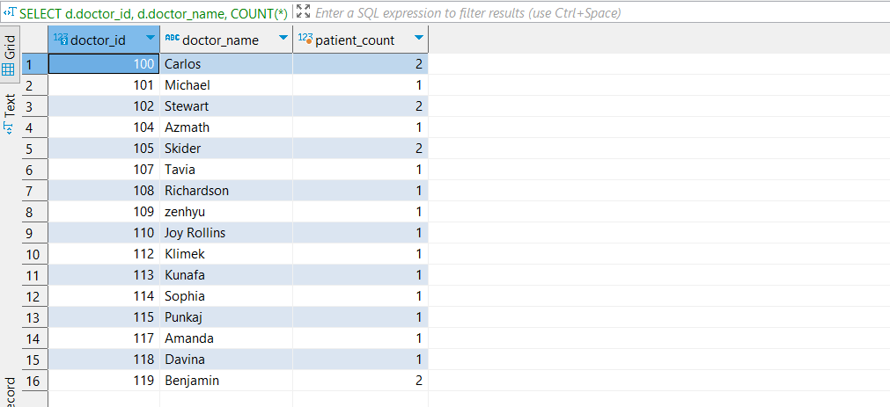

# Report on Patients with Most Prescriptions

**Explanation**: This report identifies the top 10 patients who have received the most number of prescriptions. It helps the healthcare provider to identify patients who may need more attention, as they are likely to have complex medical conditions that require multiple medications.

**Business Benefit**: This report can help the healthcare provider to optimize medication management for these patients, ensuring that they are receiving appropriate dosages and avoiding potential interactions or side effects.

SELECT p.patient_id, concat(p.first_name, ' ', p.last_name ) as patient_name, COUNT(*) AS num_prescriptions

FROM patient p

INNER JOIN prescription_report pr ON p.patient_id = pr.patient_id

GROUP BY p.patient_id, patient_name

ORDER BY num_prescriptions DESC

LIMIT 10;

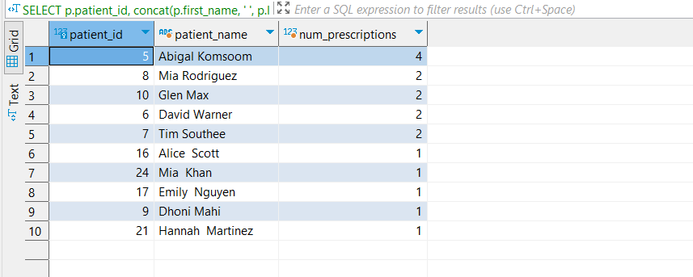

# Report on Patients with High Medical Costs

**Explanation**: This report identifies patients who have incurred high medical costs, which may be an indication of complex medical conditions or significant medical interventions. It helps healthcare providers to identify patients who may need more comprehensive care and monitoring.

**Business Benefit**: This report can help healthcare providers to optimize their resource allocation and financial management, ensuring that they allocate resources efficiently and effectively.

SELECT p.patient_id, concat(p.first_name, ' ', p.last_name ) as patient_name, SUM(b.bill_amount) AS total_medical_costs

FROM patient p

INNER JOIN billing b ON p.patient_id = b.patient_id

GROUP BY p.patient_id, patient_name

HAVING total_medical_costs > 100

ORDER BY total_medical_costs DESC

LIMIT 10;

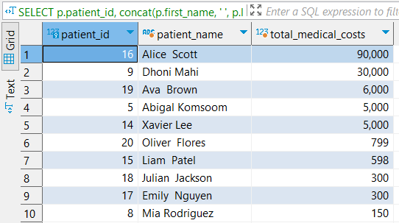

# Report on the Number of Patients Discharged on Each Day

**Explanation**: This report provides information on the number of patients discharged from the hospital on each day. It uses the UNION ALL operator to combine the discharge dates from the discharge_period table and the appointment dates from the appointment table where the patient's height, weight, and treatment information is not null. The combined results are then grouped by the discharge date and the COUNT function is used to count the number of patients discharged on each day.

**Business Benefit**: This report can help the hospital to monitor the number of patients being discharged each day, which can help in resource allocation and capacity planning. It can also be used to identify trends and patterns in patient discharges, which can be used to optimize the hospital's operations.

SELECT discharge_date, COUNT(*) AS num_patients

FROM (

SELECT discharge_date

FROM discharge_period

UNION ALL

SELECT appointment_date

FROM Appointment

WHERE height IS NOT NULL AND weight IS NOT NULL AND treatment_for IS NOT NULL

) AS all_dates

GROUP BY discharge_date

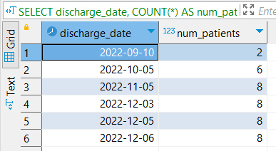

# Report on the patients who have had lab tests for all their diseases

**Explanation**: This report provides information on the patients who have had lab tests for all their diseases. It uses a subquery to retrieve the disease types for each patient from the disease_infected table and another subquery to retrieve the disease types for each patient from the lab_record table. The EXCEPT operator is used to find the disease types that are not present in the lab records. The outer query uses a NOT EXISTS condition to filter the results and show only the patients who have lab records for all their diseases.

**Business Benefit**: This report can help the hospital administration to monitor the quality of the medical care provided to patients. It can also help the hospital to identify the areas where improvements are needed in the lab testing process.

SELECT p.patient_id, CONCAT(p.first_name ,' ',p.last_name ) as full_name

FROM patient p

WHERE NOT EXISTS (

SELECT di.disease_type_id

FROM disease_infected di

WHERE di.patient_id = p.patient_id

EXCEPT

SELECT lr.disease_type_id

FROM lab_record lr

WHERE lr.patient_id = p.patient_id

)

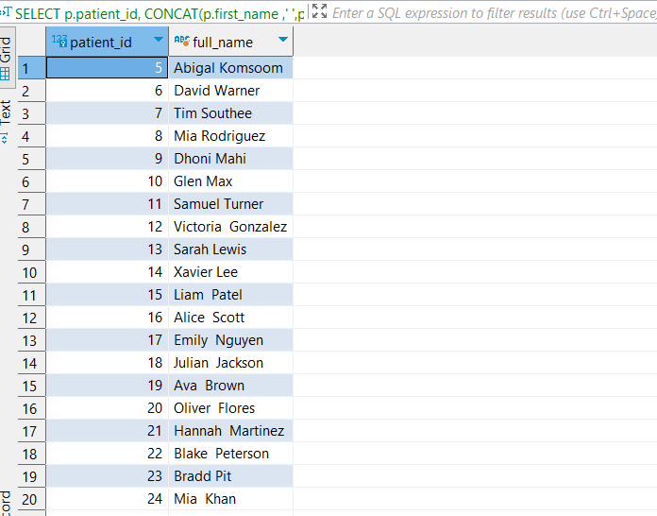

The above project provided a structured way to organize and analyze hospital data. The various tables with their columns helped in categorizing data points, providing a better understanding of patient information, doctor specialization, appointments, billing, and patient history. The use of joins, aggregate functions, subqueries, and single-row functions allowed for efficient data retrieval and analysis, providing insights into various aspects of the hospital's operations. The project's reports on patients with chronic diseases and the number of patients discharged on each day helped in identifying trends, patterns, and areas for improvement, which can be used to optimize the hospital's operations and provide better care for patients. Overall, the project helped in better visualization and analysis of hospital data, providing insights into different areas of the hospital's operations, resource allocation and patient care.